Lighthouse Promise, Inc.
Annual Report FY 2015
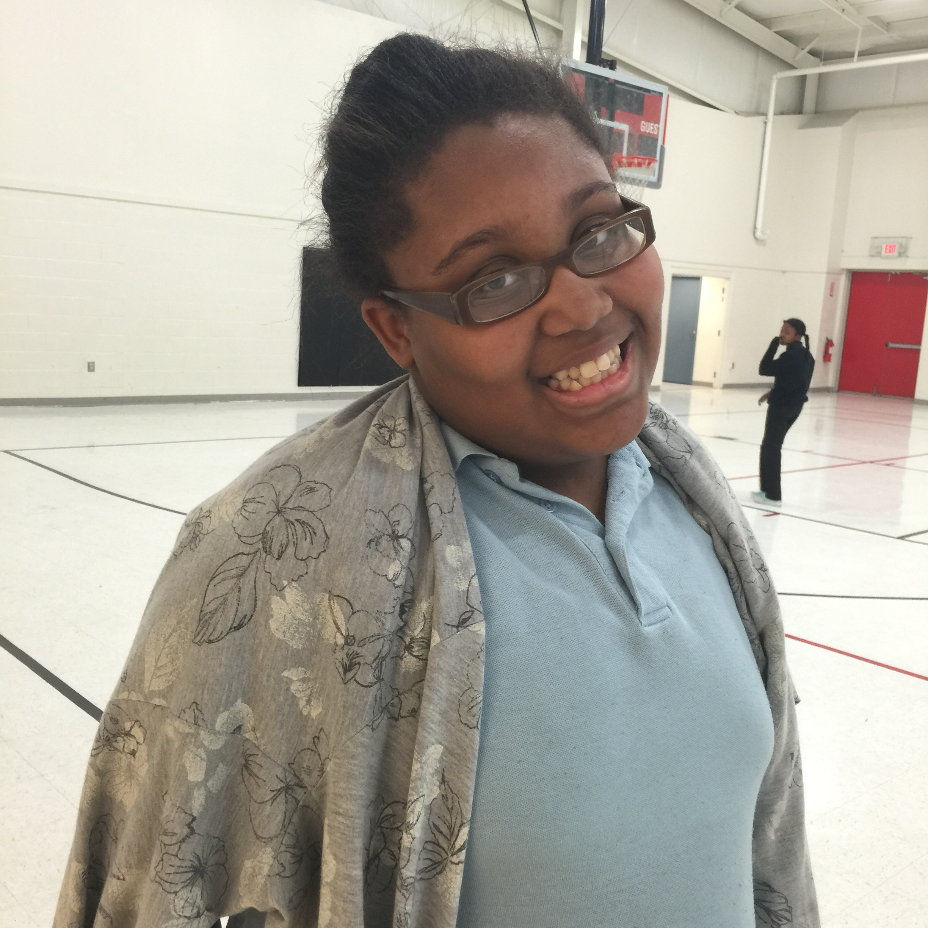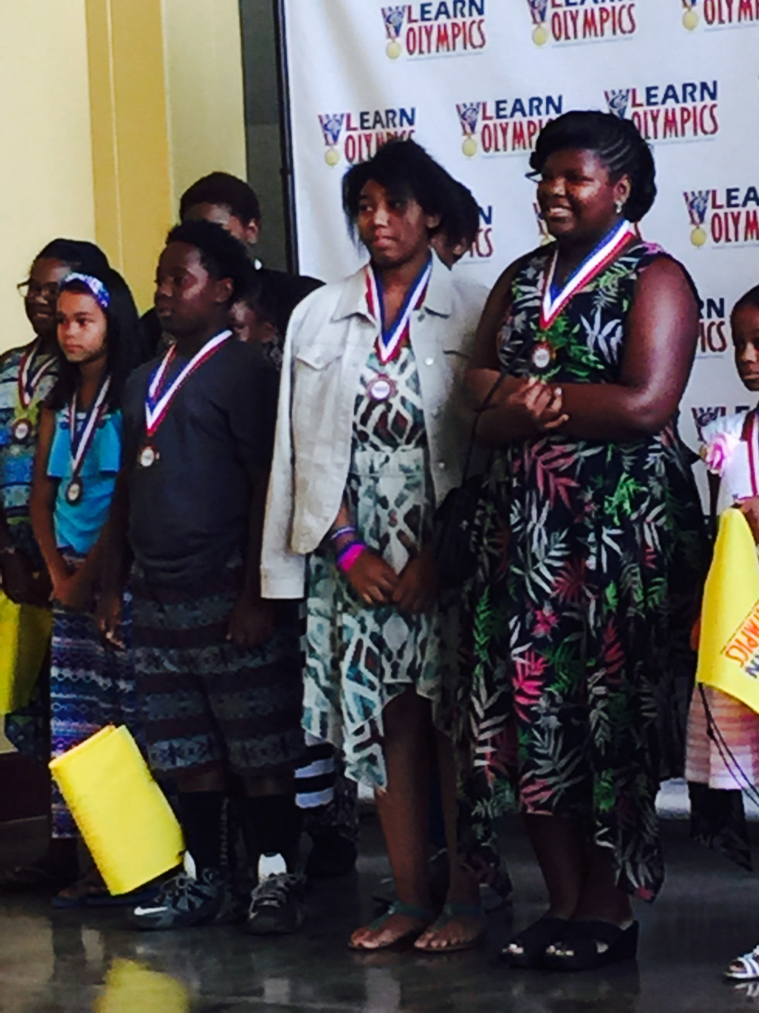

[“You can easily change the formatting from the Quick Styles gallery on the Write tab.”]
Community Center --- Academy at Newburg --- Athletic Center

A 501 (C) (3) Organization
5312 Shepherdsville Road, Louisville, KY 40228
502-964-5909
www.thelighthousecenter.org

Lighthouse Promise, Inc.
Annual Report FY 2015

Mission Statement………………………………………………………….3
Letter to Friends of Lighthouse with 2015 student results…………………………………………………………………………3-11
Gym Activities……………………………………………………………….12
Fund Raisers during the year……………………………………………..12
Finances and Budget……………………………………………………….13-14
Assets……………………………………………………………..................15-16
Privacy Policy........................................................................................16
Board Officers and Board Member Information……………………… 17

Lighthouse Promise, Inc.
Annual Report FY 2015

LIGHTHOUSE MISSION STATEMENT
The Lighthouse is a vital force in the Newburg Community and surrounding areas to help children and youth achieve higher academic levels; encourage them to cultivate a love for the arts; and motivate them to develop their potential to become moral and spiritual leaders in their community. Our Mission is to bring about long term spiritual, educational, and economic renewal and growth in this community by working in partnership with families, churches, Jefferson County Public Schools, Kentucky Department of Education, Foundations, Businesses, and Agencies.
Dear Friends,
We look back on 2015 filled with gratitude for your investment in Lighthouse Promise, Inc. This report will show that we are delivering the promise we made to you, our community and stake holders. We continued our efforts as a 21st Century Community Learning Center aiding students academically, emotionally, and socially. Lighthouse has been added onto JCPS Louisville Linked/211 system to make sure all students who need us, locate us and are participating in the 3rd Grade Reading Pledge! Lighthouse is proud to be the 2014/15 winner of eLearn Olympics High Performing Out of School Time Program and have 28 current medalists attending our facility! We also are partners with the FACE IT program whose goal is to wipe out Child Abuse in Louisville. In addition, Lighthouse meets all 20/20 Better Business Bureau Charity Accountability Standards. We are very thankful for all we have accomplished and wish to thank each of you for your help in accomplishing our goals.
Some of the highlights of 2015 are:
- In 2015, we formed 3 new “Doing Business As” falling under the umbrella of Lighthouse Promise, Inc.
LIGHTHOUSE ACADEMY AT NEWBURG: Programs such as our 21st Century Community Learning Center Out of School Time Educational Program, our GED program, our Boys 2 Men and HALO programs, and other educational programs.

LIGHTHOUSE COMMUNITY CENTER Programs such as our Health and Back to School Annual Event, facility rental, and other events that affect the community as a whole.

LIGHTHOUSE ATHLETIC CENTER: Programs such as our Basketball, Cheerleading, and other sports related activities.

- We served 110 students from January-May, 117 students in our summer program, and 106 students from September-December. Not included in this count is our full Karate program attendees, full year round basketball program, GED students per every 6 weeks, H.A.L.O. and Boys 2 Men mentoring programs.
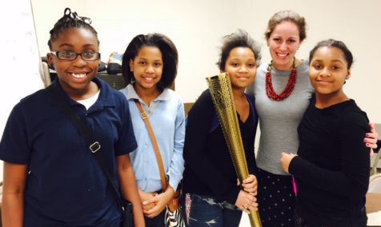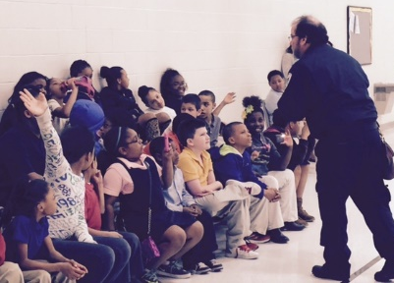
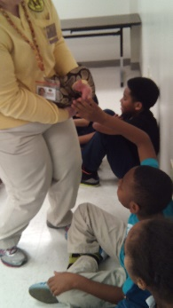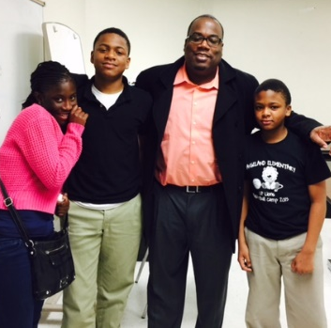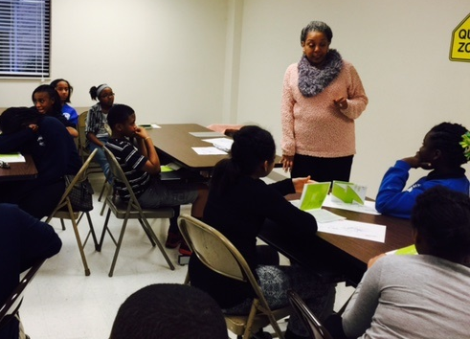
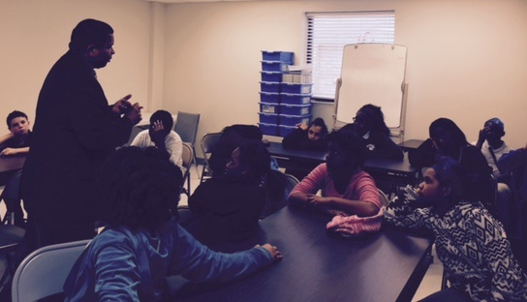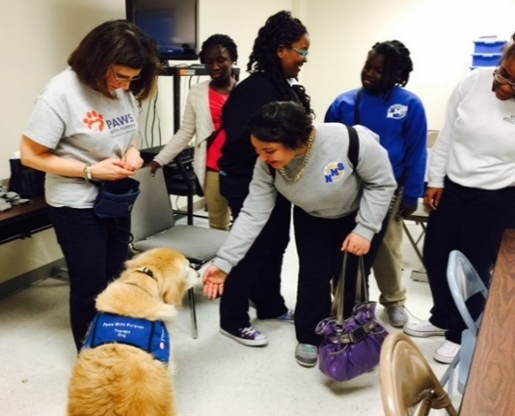
Pictured above: Speakers from Brown Foreman, UPS, Louisville Zoo, Metro United Way, LG and E, Paws with a Purpose, Kasey Foundation, Lawrence Smith-Reporter—only SOME of our amazing speaker/partners!

- We continue to partner with JCPS, Kentucky Department of Education, and Metro Louisville to insure a quality program. In addition, we meet all 20 Better Business Bureau Standards.

- Lighthouse is endorsed by Jefferson County Public Schools as an Endorsed Learning Site, we are listed on JCPS Louisville Linked, we participate in 3rd Grade Reading Pledge, and are the 2014/15 winner of eLearn Olympics High Performing Out of School Time Program. We continue our partnership with JCPS to include utilizing the Every 1 Reads Program as well as Study Island research based computer programs. This allows us to tie directly into the student’s school day.
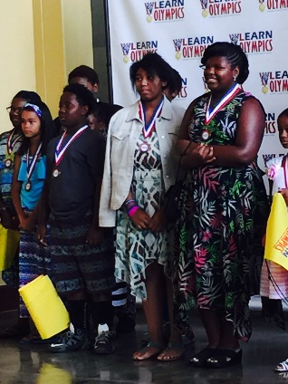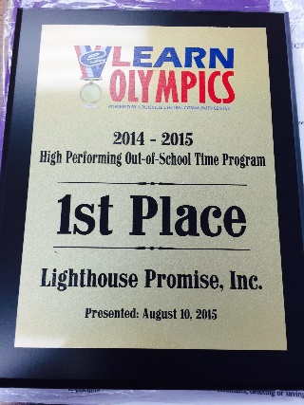

- Lighthouse student attendance at their Jefferson County Public School was higher than their average peers. Student attendance for the year was at 97.4% compared with the middle/elementary JCPS average of 94.6. (JCPS has a goal of student attendance to be 96%)

- Lighthouse participated in the Metro Louisville program, Out of School Time Quality Standards. Lighthouse exceeded the standards required by Metro Louisville to be a quality program.

- Data on Our Success:
Fall 2014 to Spring 2015: 86% of students showed an increase in at least one core subject area or obtained the highest grade possible. 92% of students maintained or improved to a C or higher grade in at least one core subject area.
Surveys from teachers and students say:
- 98% of Teachers believe their student has improved in either academics, behavior, and/or engagement when/because of attending Lighthouse.

b. 86% of Teachers surveyed say Lighthouse has helped students complete homework more to their satisfaction. With another 8% stating that students have been turning in homework to their satisfaction throughout the year. Total of 94%.
c. 93% of Teachers say that since attending Lighthouse students are getting along better with others.
d. 88% of Students feel Lighthouse is instrumental in their achievement at school.
e. 97% of Students feel Lighthouse teaches them about things they can do in the future: ie: College and Career Readiness options.
- The number one teacher comment on report cards say Lighthouse students are participating more in group discussions at class and behavior is improving.

- Dare to Care continues to partner with us providing hot nutritious meals for all of our students. We were awarded the Kids Café of the Year Award and a $500 check!
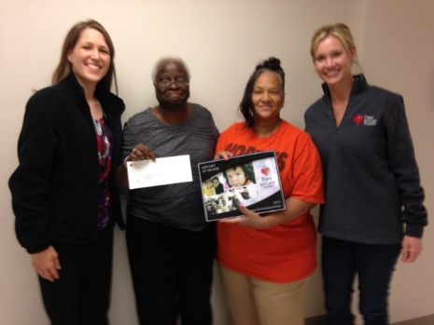
- This past summer, we hosted Science All Around expanded 5 week summer camp. With help from our partners and many volunteers, we studied and visited:
Week 1: Using Science Long Ago Trip: Riverside, the Farnsley-Mooreman House and Landing
Week two: Weather & the Universe. Trip: Rausch Planetarium
Week three: Living Things Trip: Day Camp at Lighthouse
Week four: Animals, Animals. Trip: Louisville Zoo
Week five: Science for You and Me Trip: KY Science Center
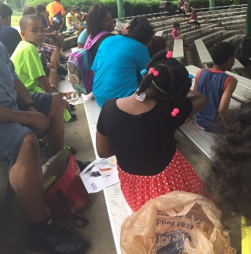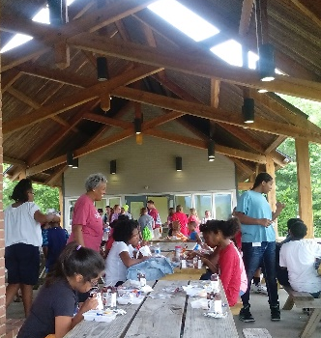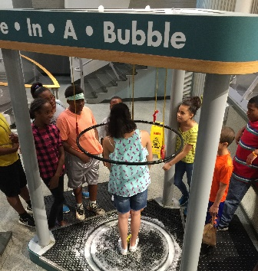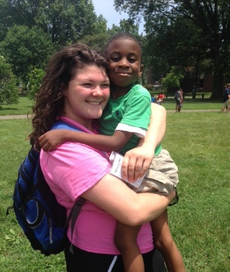

- On August 8, 2015, Lighthouse Back to School and Health Fair served 869 people this year with 620 students receiving backpacks filled with school supplies, 125 Vision Screenings, 93 Dental Checks, 83 Physicals, 200 School Uniform shirts given away, 400 Louisville Tap water bottles given away.
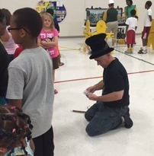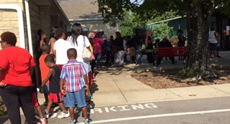

- Lighthouse offered educational programs throughout the year including STEM (Science, Technology, Engineering, and Math); Reading enrichment; College and Career Readiness programs; peace teaching programs; Junior Achievement, Speakers that encompass the community teaching on careers and college experiences; 4H; Child Psychologists; Karate; Basketball; Cheerleading; Halo (our girls Saturday mentoring program); Boys 2 Men (our boys Saturday Mentoring program); Robotics, Coding, music classes; art classes; a full GED program; weekend food backpacks; Club time teaching things like: Photography, STEP Dance, Gardening, Peace Building, computer, book club, and more.
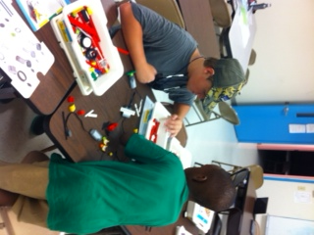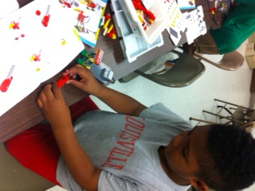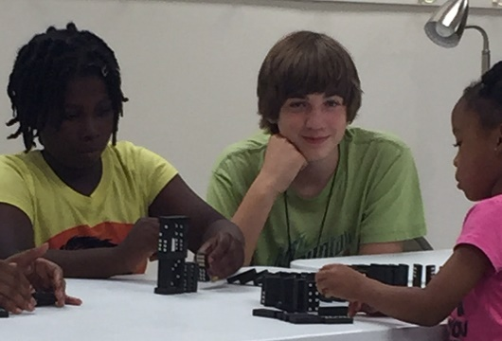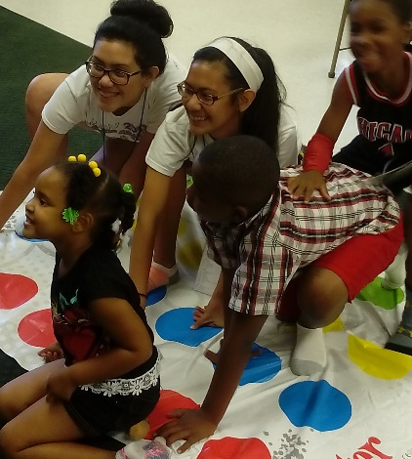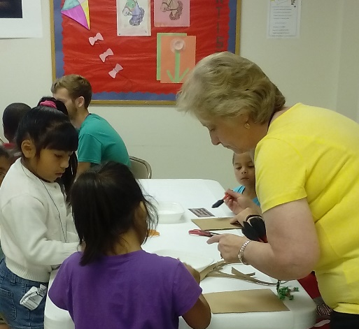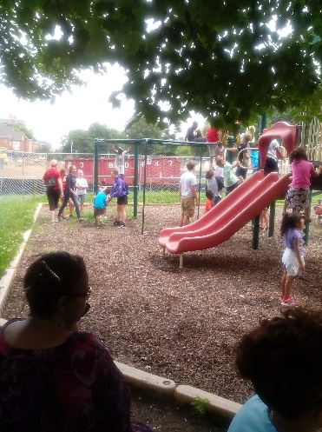

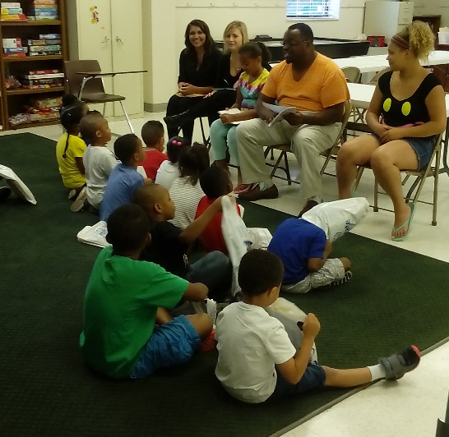
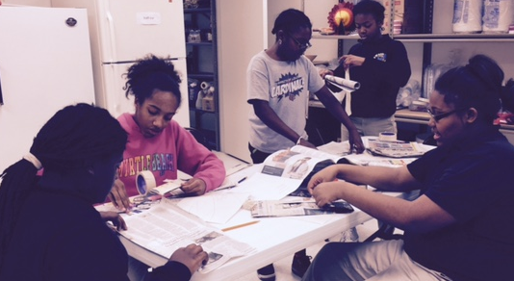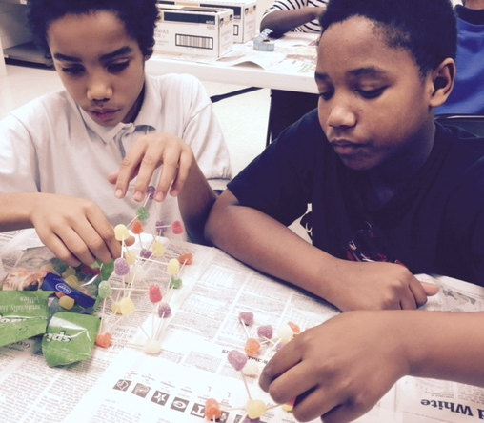

Thank you for your support of our programs since September 1999. We opened to only 4 students and have experienced tremendous growth over these past many years. We attribute our success to a strong staff, involved Board, community partnerships, church organizations, and many funders and volunteers within our community. If you are interested in donating or volunteering, please contact us at 502-964-5909. Blessings to you all!

Lighthouse Athletic Center

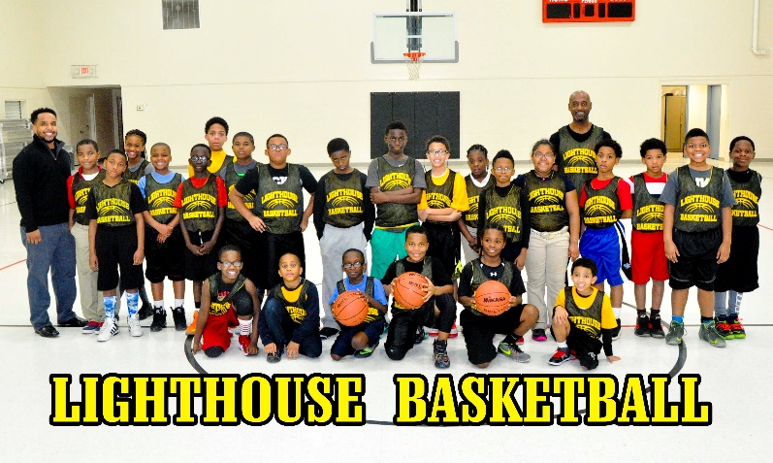

Lighthouse Fund Raisers:

- On January 10: Christ Church Sanctuary Series Orchestrapalooza Raised $ 1,200

- On June 20, we held the annual Lighthouse Walk fund raiser raising approximately $4,625.

- On August 22, the Middletown UM Men`s group sponsored the Lighthouse Golf Scramble and raised $16,828.50.

- On October 1, Lighthouse participated in Give Local Louisville raising $ 18,781.50

- In December, Steve Milam again blessed Lighthouse with his Outdoor Adventure: This is an outside of the box fundraiser where Steve camps out for 100 hours with only the items he can carry on his back. Steve raised $ 5,500.

FINANCES AND BUDGET

As part of our Annual Report enclosed are operating budget figures showing actual operating income and expenses for 2014 and budgeted figures for 2015.

2016 ESTIMATED VALUE OF “DONATIONS IN KIND”
PROGRAMMING:
Primarily volunteers classroom tutoring $ 25,000
Computer room—Volunteers 8,000
Kitchen Work—After School & Summer Program 4,000
Food from Dare to Care 35,000
Food – Other 1,000
Coaching—Basketball, CheerLeading 5,000
Other—Advisory and Program Committees 3,000 $ 81,000
HEALTH FAIR—Drs.,Nurse, LH Directors, LGE, Other volunteers $ 8,000
FUND RAISING: --Volunteer Hours
Concerts-Walks-LWC Singers,BUC, LH Directors $ 14,000
Golf Scramble—MUMCM, LH Directors 12,000
Outdoor Adventure, Other—Steve Milam, Restaurants, etc. 5,000
$31,000

Work Parties—GE, UPS, Churches, Youth Groups, Scouts, etc. $ 4,000
Finances, Treasurer, Accounting, Clerical, Legal $ 20,000
M.C. Sales & Services—Steve Culler, Supplies, Floor Cleaning $ 8,000
Trustees, Maintenance, Projects, Painting, Landscaping $ 10,000
Mowing, Trimming, Pick up, Litter, etc. $ 3,000
Collecting School Supplies, Backpacks, etc. $ 13,000
Estimated Value of 2016 “Donations in Kind” for year 2016 $178,000

Lighthouse Fixed Assets 12/31/15

Fixed Assets

Building Expenditure thru 12/31/15 $ 1,322,222
Church Building 250,000
Garage 20,000
Land 250,000
Contents 140,000 ____________________________________________________________________________

Total Fixed Assets $ 1,982,222 Less Depreciation 288,765

Total Estimated Net Fixed Assets 12/31/15 $ 1,693,457
Our 18,600 sq. ft. Lighthouse Promise, Inc. building is operating at capacity. The building is completely paid for.

Total Lighthouse Assets 12/31/15

Total Assets

Cash Available for Operations as of 12/31/15 $ 668,845
Contents and other personal property 140,000
Land 250,000
Buildings 1,592,222

Total Assets as of 12/31/15 2,651,067

Less Depreciation 288,765

Total Estimated Net Assets as of 12/31/15 $ 2,362,302

Lighthouse Privacy Policy:
Your privacy is important to us. To better protect your privacy we provide this notice explaining our information practices. Our privacy policy is simple: we collect no information about you unless you choose to provide that information to us. In addition we do not give share sell, or transfer any personal information about you to any third party. To prevent unauthorized access, maintain accuracy, and ensure the correct use of information, we have put in place procedures to safeguard and secure any information we collect. If you have questions about our privacy practices, please contact us at either the postal or email address posted on this annual report.

************Lighthouse Promise, Inc. is approved by the
Better Business Bureau Charitable Review Committee.********************

2015/2016 OFFICERS OF LIGHTHOUSE PROMISE, INC.
Al Kirkpatrick, Chairman of the Board
Steve Bays, Vice Chair
Nancy Parker, President
Jack Swann, Treasurer
JoAnn Burch, Secretary
Cynthia Overall, Director of Programs

Lighthouse Board of Directors
Allison | Barbara | RegisteredDietition
Austin | Dan | School Supt.-retired
Bays | Steve | Consultant - Six Sigma
Beard | Richard | retired
Bishop | Nicole | Autism Specialist for JCPS
Bishop | Wayne | U.M. Clergy-retired
Broughton | Russell | Market Development Mgr. - retired
Bodine | Claudia
Burch | JoAnn | retired
Cooper | Bill | Attorney
Cox | Dan | Exe. Vice pres ERC Solutions
Curry | Rebecca | Louisville UMC District Supt.
Drescher | David | Exec.VP marketing - retired
Edwards | Larry | CPA
Findley | Tim | Minister
Ioos | Richard | retired
Kirkpatrick | Albert | Human Resources - retired
Kirkpatrick | Judy | teacher-retired
Milam | Steve | Ford Motor-Manufacturing Advisor
Overall | Cynthia | Director
Overall | Thomas | UPS -United Parcel Service
Parker | Nancy | Grant Writer for Lighthouse
Peters | Rhoda | Ky Conference Provost/teacher- ret
Scherzer | Mabel
Scott | Ophelia | retired
Sodergren | Mel | CPA
Sutton | James | Financial mgr. - retired
Swann | Jack | Science Teacher - Retired
Townsend | Wendell | GE Mgmt. - retired
Weaver | Rhynia | International pilot - retired
Wellman | Carol | Music Teacher - Children`s Minister

