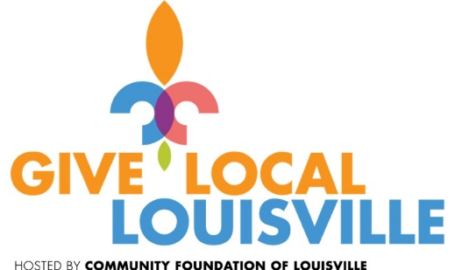

|  |
| --- |
| MISSION STATEMENT  The Lighthouse Community Center is a vital God-driven force in the community helping children and youth achieve higher academic levels; encourage a love for music, art, drama and dance; and motivate them to develop their God-given potential to become moral and spiritual leaders in their community. Our Mission is to bring about long term spiritual, educational, and economic renewal and growth in this community by working in partnership with families, area churches, schools, businesses, and agencies. |
|  |
| Important Dates:  October 1 : GIVE LOCAL LOUISVILLE  October 13: Joe’s OK Bayou Fundraiser |

This year Lighthouse is participating in the Community One Day of Giving, called” Give Local Louisville” on October 1, 2015. Sponsored by the Louisville Community Foundation, this 24-hour, online “Give Day” will help support Lighthouse as well as over 350 other nonprofits in the Louisville area.

GREAT NEWS! *Give on this day and your giving will be matched up to $10,000!* In addition, Community Foundation of Louisville and its partners LG&E and KU Energy, Anthem Blue Cross Blue Shield of Kentucky, Delta Dental of Kentucky, WHAS 11, WLKY, the Courier-Journal, Sam Swope Auto Group and a generous anonymous foundation have a fund set up to proportionally match the donations received along with having cash prizes throughout the day awarded to the charities.

Everyone can be a Philanthropist! AND YOUR DOLLAR WILL BE MATCHED DOLLAR FOR DOLLAR UP TO $10,000!   On **Thursday, October 1, 2015**, please consider donating online to The Lighthouse Community Center during the community wide Give Local Louisville event, sponsored by the Louisville Community Foundation.

The Lighthouse has a goal of $10,000 and we can only meet this goal if our generous supporters make their online donations between 12:01am Oct. 1-11:59pm Oct. 1. Mark your calendar today! Just type this link into your browser: <https://www.givelocallouisville.org/#npo/lighthouse-promise-inc>. Or, go to the Lighthouse website at [www.thelighthousecenter.org](http://www.thelighthousecenter.org) and click on Give Local Louisville under the What’s New link. This will lead you directly to the donation page.

Every dollar is important and your support and participation is needed to make this event successful and allow Lighthouse to continue its role shaping the lives of youth in the Newburg area. Please contact any Board Member with questions.









**Lighthouse Completes Successful “Science All Around” Summer Camp**

Lighthouse is excited to announce our successful completion of our expanded 5 week summer day camp program, Science All Around. This Monday through Thursday learning-palooza began on June 15 with weeks broken out into themes. Week 1: Theme: **Long Ago** (Science in History) - Participants engaged in activities related to 19th Century economics (riverboat trade, farming), and gardening. We concluded the week with a trip to the Farnsley Moreman Landing and participated in an archeological dig. Week 2: Theme: **Weather and the Universe** (Weather science and technology) - Participants engaged in activities related to weather, weather forecasting and astronomy. We concluded the week with a visit to Rauch Planetarium and tour at the University of Louisville. Week 3: Theme**: Living Things** (Science in Nature) - Participants engaged in activities related to biology (habitats, regional animals and plants). Week 4: Theme: **Animals, Animals** (Science in Zoos)-Participants engaged in activities related to animals and their care, zoos and zoo planning. We concluded the week with a field trip to the Louisville Zoo. Week 5: Theme: **Science for You and Me** (Construction and Technology). Participants engaged in activities to construct objects and projects using concrete materials (towers, pump rockets, paper planes) and computer technology (program coding activities). We concluded this week with a field trip to Kentucky Science Museum. Included in the weeks is participation in Louisville Public Library Summer Reading program, DEAR reading time/one on one reading time, enrichment activities, club time, and more. The entire summer program is FREE OF CHARGE including the field trips. We were blessed this year by PATH/MFUGE weekly volunteers!

**Lighthouse Personnel Changes**

It is with sincere appreciation for the wonderful job performed by Dr. Ophelia Scott that the Board accepts her resignation as she pursues most deserved retirement activities. Cynthia Overall accepted the position as Director of Operations & Student Services and has been warmly welcomed by the students and staff. Also, Nancy Parker is our Director of Partner Relations and Joyce Jenkins is our Administrative Assistant. Welcome also to Jeff Johnson and his wife, Tammie Everett who serve as our Gym Coordinators.

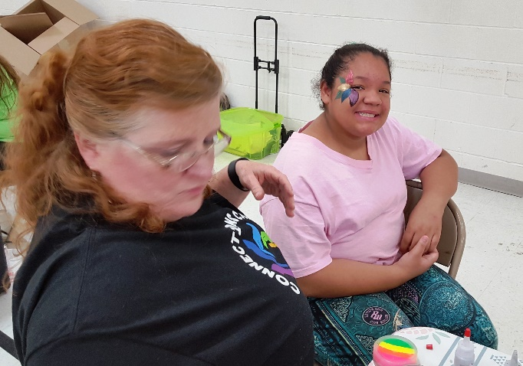

Face painters were a huge hit with the attendees.

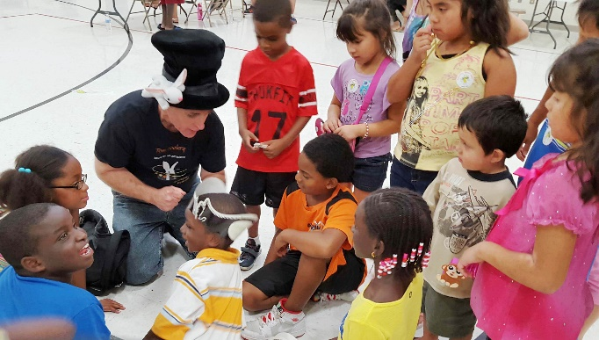

Children (and adults) were amazed by the volunteer magician

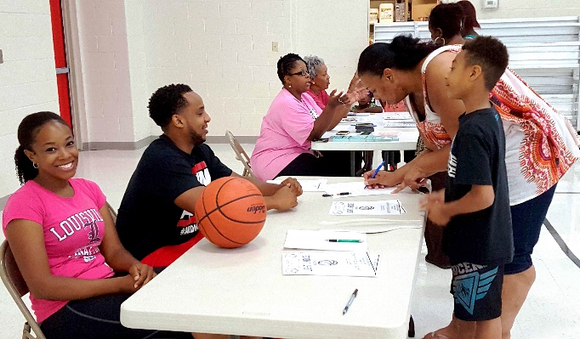

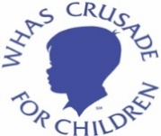

**LIGHTHOUSE BACK TO SCHOOL FAIR**

As we closed the doors on the Back to School/Health Fair at the Lighthouse on Saturday, August 8, 2015, all the “worker bees” were beaming with happiness. The joy we were able to bring to the folks that came was just great. We had so many folks saying “thank you” and “bless you for what you are doing”, it really made us feel good.

Of course, none of that would have been possible if not for your generosity. Lighthouse was blessed by all the school supplies donated by church and local organizations. With your help, we were able to have the most successful fair to date. Our volunteer physicians and nurse practitioner along with Galen Nursing students performed 83 physicals, University of Louisville dental students performed 93 dental checks, and South Oldham Lions Eye Club volunteers performed 125 vision screenings. Middletown Methodist Church provided 200 school uniform shirts, Louisville Water Company donated 400 water bottles and many organizations donated fully equipped backpacks. The total number of people registered was 869, a new record. This was an event that resulted in blessings for all, the recipients, as well as all the Lighthouse volunteers!

The event would not have been successful without the generous support and donations of the Louisville Water Company, WHAS Crusade for Children, Louisville Gas and Electric, Good Samaritan Foundation of the United Methodist Church, University of Louisville Dental School, Galen School of Nursing, Dr. Dennis Gray, Dr. Madison Ryle, Dr. Jim Wright, Theresa Goodman, NP, face painters, magician, and school volunteers who gave of their time and talents.

We look forward to next year’s event which is scheduled for Saturday, August 6, 2016.



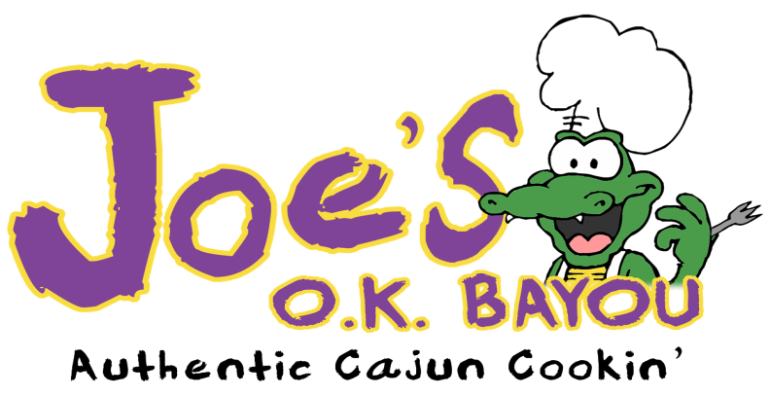

http://www.joesokbayou.com/



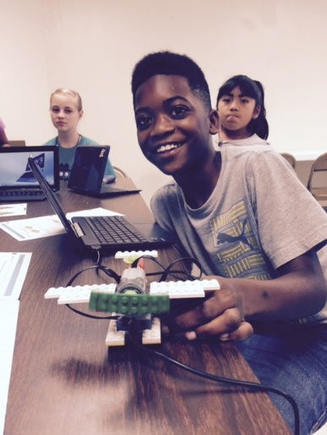

**FUNDRAISER AND SOCIAL EVENT**

**There will be a** **Lighthouse Center fundraiser at Joe's OK Bayou at 9874 Linn Station Road (in Plainview Shopping Center down from Kroger's) on Saturday, October 13, for lunch and dinner. There will be free live music from 6-8pm. Grab some friends and head to Joe’s OK Bayou from 11am to closing at 9pm and enjoy delicious Cajun dishes. The Lighthouse Center will get 25% of all total sales when the Lighthouse flyer is presented. The flyer is available for download from our website. Click on the link in the What’s New Calendar Event on the home page.**

**VOLUNTEER OPPORTUNITY 1 HOUR A MONTH**

Do you have **1 hour a month** to be a**Tuesday Study Buddy** for a Kindergarten, 1st, 2nd, or 3rd grader from the Newburg area? We are looking for a team of volunteers to commit to doing just that on Tuesdays from 4:30 - 5:30 at the Lighthouse Community Center located at 5312 Shepherdsville Road. You would be working with the same child each month by helping them with their homework, reading with them, playing games with them and basically just being a friendly encouragement to them. If you are interested, you would begin working with your assigned student in October. These students really relish this 1-on-1 time with their Study Buddy. They especially like it when men work with them as they often do not have good male role models in their lives. If Tuesdays do not work for you, students come to Lighthouse Monday through Thursdays and there are always needs for volunteers each day. Even if this is not something you feel you can do at this time, could you pass this information on to others who just might be willing to help? Anyone interested or if you have any questions, please contact Judy Kirkpatrick at[judygailh@gmail.com](mailto:judygailh@gmail.com) or call her at (502) 245-7160.



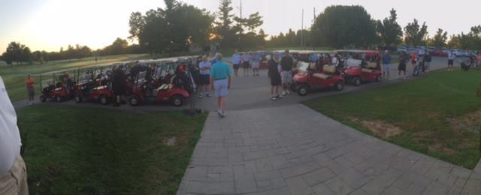

**FACEBOOK STATISTICS**

**Weekly Avg**

Page visits 27

Weekly Total Reach 4,314

People Engaged 306

Message Response Rate 100%

Total Page Likes* 251



**Annual Middletown Masters Golf Scramble**

On August 22nd, 72 golfers teed off at Long Run Golf Course on a beautiful Saturday morning to enjoy a fun filled day for a great cause, **the Lighthouse Community Center**. The results were a wonderful **$16,569**, all of which goes directly to Lighthouse. This year, there were golfers from many area churches which helped us reach this record amount. Many thanks to Middletown United Methodist Church and their Methodist Men’s group for organizing this event.

**KROGER COMMUNITY REWARDS REGISTRATION INFORMATION**

Would you like to help the Lighthouse raise funds while shopping at your friendly neighborhood Kroger? Follow the instructions below:

* Register online at [krogercommunityrewards.com](http://krogercommunityrewards.com/)
* Be sure to have your Kroger Plus card handy and register your card with your organization after you sign up.
* If you do not yet have a Kroger Plus card, they are available at the customer service desk at any Kroger.
* Click on Sign In/Register
* Most participants are new online customers, so they must click on SIGN UP TODAY in the ‘New Customer?’ box.
* Sign up for a Kroger Rewards Account by entering zip code, clicking on favorite store, entering your email address and creating a password, agreeing to the terms and conditions
* You will then get a message to check your email inbox and click on the link within the body of the email.
* Click on My Account and use your email address and password to proceed to the next step.
* Click on Edit Kroger Community Rewards information and input your Kroger Plus card number.
* Update or confirm your information.
* Enter NPO number or name of organization, select organization from list and click on confirm.
* To verify you are enrolled correctly, you will see your organization’s name on the right side of your information page.
* REMEMBER, purchases will not count for your group until after your member(s) register their card(s).
* Do you use your phone number at the register?  Call [800-576-4377](tel:800-576-4377), select option 4 to get your Kroger Plus card number.
* Members must swipe their registered Kroger Plus card or use the phone number that is related to their registered Kroger Plus card when shopping for each purchase to count.
* **Individuals must re-register every August**